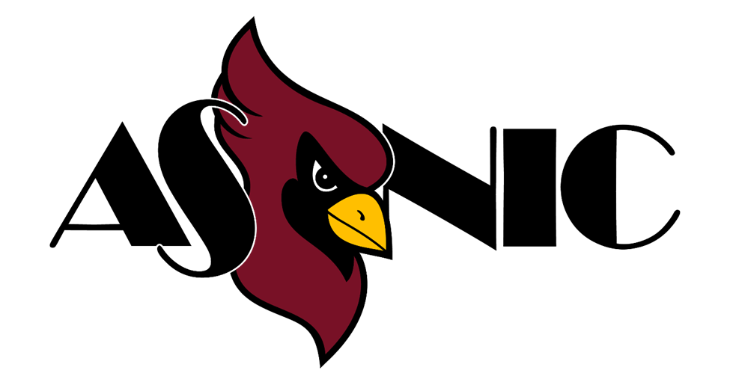

ASNIC Student Club Handbook

Introduction

The North Idaho College Department of Student Involvement and the Associated Students of North Idaho College (ASNIC) Student Government are committed to student success and to providing opportunities for personal growth and group development. Through clubs, students gain valuable leadership experience and build strong connections within the NIC community. Recognized clubs help create a sense of belonging and provide meaningful ways for students to get involved in campus life.
This handbook is provided by ASNIC Student Government to support clubs in their organizational development, event planning, and goal achievement, while also encouraging them to make a positive impact on both the NIC campus and the broader community.
To further support clubs, ASNIC has established the Intra-Club Council (ICC), which provides official recognition for clubs and serves as a public forum where they can share their needs and interests. The ASNIC Constitution and By-laws outline the authority, scope, and purpose of ASNIC-recognized clubs.
The ASNIC Club Handbook is reviewed annually by the ASNIC Vice President and the Intra-Club Council to ensure consistency with NIC’s mission and code of conduct. It serves as a guide to the creation, development, operations, and management of ASNIC Clubs.
For this handbook, all ASNIC-recognized clubs and organizations will be referred to simply as “Clubs.”
Final Interpretation of club policies rests with the ASNIC Student Government and Department of Student Involvement.

ASNIC Student Government & Student Involvement Office

The ASNIC Student Government and the Student Involvement Office are here to support students interested in joining or starting a club at North Idaho College. The ASNIC Vice President and ASNIC Advisors are valuable resources who can guide you through the process and answer your questions.
If you have questions not addressed in this handbook or need additional assistance, please don’t hesitate to contact us.

ASNIC Vice President & Marketing Coordinator: ASNIC.SG@nic.edu
ASNIC Office: (208) 769-7761 / ASNIC.CLUBS@nic.edu
Matt Huylar – Coordinator of Student Involvement: (208) 769-7841 / mghuylar@nic.edu
Steve McGroatry - Accountant of Auxiliary Services: (208) 769-5913 / smmcgroarty@nic.edu
Note: Appointments are not required but are strongly encouraged.

Intra-Club Council (ICC)

The Intra-Club Council (ICC) is made up of one representative from each ASNIC-recognized club, with the ASNIC Vice President serving as chair.
ICC typically meets on the first Tuesday of every month during the academic year. Each club must have a representative present at every meeting in order to remain active and maintain access to their club budget. Clubs may request to be excused if prior notice is given to the ASNIC Vice President or Student Involvement Coordinator.
The ICC has limited governance over club affairs, focusing on authorizing new clubs and supporting the sustainability of active clubs. Monthly meetings provide a space to approve new clubs, share projects and activities, and review any updates to procedures outlined in this handbook. Meetings also serve as a forum for collaboration, outreach, and discussion on how to strengthen the overall clubs program.
ICC members are encouraged to propose changes to the ASNIC Club Handbook or club procedures. Any revision recommendations approved by ICC will then be submitted to ASNIC Student Government for final approval by majority vote.

Starting a New Club

Clubs at NIC are student-initiated and student-led, designed to support a wide range of student needs and interests. They provide opportunities for involvement, leadership development, and community building. All currently enrolled NIC students are welcome to join clubs at no cost.
Students may apply to start a new club at any time during the academic year by completing the application process outlined below.

Steps to Start a Club
- Assemble a group of at least five currently enrolled NIC students. At least two students must serve as officers (President, Vice President, Secretary, Treasurer, etc.).
- Complete and gather the required documents listed below.
- Meet with the ASNIC Vice President or the Student Involvement Coordinator to review paperwork, ICC requirements, campus policies, and procedures.
- Present your new club proposal at an upcoming ICC meeting.
Required Documents (all included in the New Club Application, available at NIC Clubs Resources):
- Application to Start a Club (see Appendix)
- Advisor Agreement
- Club Constitution
- Club Roster (minimum of five members, with two serving as officers)
After presenting at ICC, club status is determined by a majority vote of ICC participants (one vote per recognized club. If a student is representing more than one club at the ICC meeting, they can only cast one vote).
The Student Involvement staff and ASNIC Student Government (ASNIC SG) are available to support students throughout this process.

Benefits of Official Recognition
Clubs approved by ICC receive the following benefits:
- One-time startup funds of $250 (based on available funds)
- Free use of campus facilities (unless additional direct costs are incurred)
- Eligibility to apply for additional funding through the ASNIC SG FAST Grant process
- Access to supplies in the ASNIC Suite - Student Union Building (SUB 233)
- Invitations to student development and leadership opportunities
- Advertising privileges on campus bulletin boards and other official outlets
- Ability to conduct approved fundraising for club activities
- Eligibility for ASNIC-related awards and recognition, including end-of-year ICC awards (based on available funds)

Organizations

Like clubs, organizations at NIC are student-led and designed to support a variety of student needs and interests. The key difference is that an organization is typically a chapter or branch of a larger, nationally or regionally recognized group. Examples include honor societies, political groups, and professional associations such as medical or business management societies.
Organizations provide excellent opportunities for involvement, leadership, professional development, and community building. They may also have specific membership requirements, such as a minimum GPA, a particular field of study, or membership fees.
Organizations are held to the same standards and enjoy the same resources as clubs, with some differences in funding options. Details about those differences can be found in the Finances section of this handbook.

ASNIC Club Responsibilities

To be officially recognized by the ICC, all ASNIC Clubs must adhere to the following:

Membership
- Each club must maintain a minimum of five currently enrolled NIC students. (Five members are required to start a new club, two of whom must hold officer positions.)
- NIC employees may not be club members without prior approval.
- Community members, including NIC alumni or students enrolled elsewhere, may not join.
- Those enrolled at U of I or LCSC and taking classes at their Coeur d’Alene campuses may join NIC clubs but cannot start one.
- Clubs must remain open to all eligible students.
- Club members may be removed following this procedure (unless otherwise specified in the club’s constitution and bylaws): A meeting is held with a quorum, including the club advisor and the member in question. The member in question presents their case. A vote is conducted and must pass by a 2/3 majority.

Officers
- Each club must designate at least two officers, including a President and one other officer.
- Officers are encouraged to rotate roles annually and may not serve more than four semesters in the same position.

Advisor
- At least one of the club’s advisors must be full-time NIC faculty or staff.
- Advisors must agree to the roles and responsibilities outlined in the ASNIC Club Advisor Agreement (see Appendix).
- With prior approval, clubs may appoint an additional community advisor to provide expertise not available on campus.
- Clubs may have up to three advisors.

Club Meetings
- Clubs must meet at least twice per semester during the academic year.
- Meetings must be advertised via the NIC Events Calendar to count toward meeting requirements.
- Clubs may not hold meetings during the summer without prior approval.
- Official off-campus meetings require an advisor or an alternative college non-student employee to be present.

ICC Meetings
- Each club must have a representative at every ICC meeting to remain active and maintain access to their club budget.
- Clubs may request to be excused by notifying the ASNIC Vice President or Student Involvement Coordinator in advance.
- Individuals may represent no more than two clubs at a single ICC meeting.

Club Reporting
- Club Roster: Maintain an up-to-date roster with officer designations on file with Student Involvement.
- Website Update: Update club officers and descriptions each semester.
- Annual Renew Form: Submit at the start of each academic year to maintain access to club budgets.
- Semester Overview Report: Submit fall reports by January 1 and spring reports by April 15.
- Event Release Waivers: Required for off-campus activities or events involving inherent physical risk. Keep waivers current and on file with the advisor or the Student Involvement Office.

Applicable NIC Policies
All clubs must comply with NIC policies. If conflicts arise, the NIC Policy Manual and Administrative Services Operational Guidelines take precedence (see www.nic.edu).
- Student Code of Conduct & Title IX: Clubs must adhere to NIC policies, the ASNIC Code of Ethics, and the Student Code of Conduct.
- Non-Discriminatory Policy: Clubs must remain open to all eligible students and may not discriminate based on race, color, religion, sex, age, national/ethnic origin, disability, military status, veteran status, or sexual/racial/ethnic orientation unless exceptions are allowed by law.
- NIC encourages participation from persons with disabilities. Clubs should contact the Coordinator of Student Involvement in advance for accommodation needs.

Risk Management
All ASNIC-recognized clubs must follow NIC’s Risk Management policies, which aim to provide a safe environment and reduce the college’s risk of financial loss, injury, or reputation damage.

Inactive, Disbanded, & Probationary Status

Clubs that fail to meet the outlined requirements or do not comply with ICC procedures will be deemed inactive. The ASNIC Vice President or Student Involvement Coordinator will notify clubs of this status change and confirm it at the next ICC meeting.

Inactive Status
- No official club activities, events, or meetings are permitted until the club regains active status.
- All access to club funds is suspended.
- Benefits of club membership are suspended.
- Inactive status lasts up to four semesters. After this period, club membership and funds are officially disbanded.
- Reactivated clubs are not eligible for new club startup funds.

Disbanded Clubs
- Clubs exceeding four consecutive semesters of inactive status are considered disbanded.
- Remaining club funds are returned to the ASNIC SG Reserve Account for future allocation.
- To reform a disbanded club, members must apply as a new club and follow all policies outlined in this handbook.

Probationary Status
A club may be placed on probation if any of its members fail to adhere to policies during club activities on or off campus. While on probation, clubs are restricted from travel and access to funds. Examples of actions that may result in probation include:
- Violating the Student Code of Conduct (e.g., alcohol use, smoking, illegal drugs).
- Fundraising without express permission from the Foundation Office and the Student Involvement Department.
- Spending club funds without prior authorization.

Returning to Active Status
- Inactive clubs may regain active status by updating and submitting all required forms (club roster, advisor agreement, etc.) to the Student Involvement staff, and club leadership must meet with the ASNIC Vice President or Coordinator of Student Involvement.
- Disbanded clubs are not eligible to return to active status. Members must apply as a new club and comply with all handbook policies.
- Probationary clubs must work with the Student Involvement staff to develop a plan for reinstatement.

Meetings & Events

Clubs are expected to hold events and meetings that are open to all NIC students, with a minimum of two meetings and/or events each semester. ASNIC Clubs may request the use of NIC facilities at no cost for events related to their club purpose. The following guidelines must be followed to ensure successful and compliant event planning.

Event Approval
All club meetings and events must be submitted and approved through the Event Request Form on the NIC Event Services website. The form collects details on event logistics. Forms should be submitted at least 14 days before an event and one month before large events. Clubs are encouraged to plan events a semester in advance, as short-notice requests may not be accommodated.

Advisor Approval and Club Leadership
All club events must be approved by the Club President and Club Advisor before taking place. Events should be club-driven and led by student members, not outside entities. Students are responsible for planning the majority of each event in collaboration with their advisor.

Event Location and Travel
Club events should be held on campus whenever possible. Off-campus events require prior approval from the Department of Student Involvement and must follow Risk Management procedures. Off-campus events must also include the Club Advisor or an alternative college non-student employee.

Catering
NIC Dining Services (ELIOR) in the NIC Marketplace offers a variety of catering options for club events. All food requests must be submitted at least 14 days before an event.
Policy:
- All on-campus catering must be requested through NIC Dining Services (ELIOR).
- Outside food is generally not permitted at scheduled meetings, events, or activities. Exceptions may be granted for special circumstances (e.g., off-campus events, small groups, or donated food). To request approval, contact ELIOR General Manager Peter Bowen and Coordinator of Student Involvement Matt Huylar by emailing plbowen@nic.edu and mghuylar@nic.edu.
- Bake sales and potluck-style events are not allowed.
- NIC Dining Services retains the right of first refusal for all food services on campus. Clubs may not use club funds to purchase food from other vendors without prior approval from the Department of Student Involvement and NIC Dining Services.
Catering Request Process:
- Submit your event via the NIC Event Services website.
- Create a catering order via CaterTrax (nic.catertrax.com).
- Complete a Purchase Order Request (see Club Finances).
- Provide the generated Purchase Order number on CaterTrax to finalize the order.

Contracts, Vendors, Performers, and Films
Clubs planning to use outside performers or vendors must work closely with their Club Advisor and review campus policies prior to the event. Any contracts must be submitted well in advance to the Office of Finance and Business for review, as only the Vice President of Finance and Business Affairs is authorized to sign or execute contracts on behalf of NIC. No other student or staff member may sign contracts. A certificate of insurance is required from all outside vendors and performers, and clubs are strongly encouraged to submit documentation as early as possible to allow sufficient processing time.
Clubs that wish to show a commercial film at a meeting or event must coordinate with the Department of Student Involvement to obtain proper viewing rights. All films used in club meetings or events must coincide with the clubs mission.

Sustainability and Club Footprint
When planning events, clubs should consider their environmental impact and use materials and goods that are environmentally friendly and reusable whenever possible. Clubs interested in obtaining on-campus storage must coordinate with the Student Involvement staff before purchasing items or storage containers to ensure there is a designated space available. On-campus storage is limited, and club items may not be stored off-campus.

Universal Design
Universal Design is an approach that ensures facilities, information, and activities are accessible and usable by everyone. Instead of designing for the average attendee, event organizers should plan for people with a broad range of characteristics, including native language, gender, racial and ethnic background, age, and disability. Presenters and staff must be trained to support people with disabilities, respond to accommodation requests promptly, and know who to contact regarding disability-related issues. Clubs are responsible for creating an inclusive environment where all students feel welcome at club activities.
The following accommodation statement is required on all promotional materials:
North Idaho College encourages persons with disabilities to participate in its programs and activities. If you anticipate needing any accommodation or have questions about the physical access provided, please call Event Services at 208-696-2016 before your participation or visit.
To request accommodations for club events, Disability Support Services can be reached at 208-665-4520.

Damages to Event Space
Clubs are responsible for any damages that occur to an event space during their activities. Costs for repairs or replacement will be charged to the club’s account at the discretion of NIC Facilities.

Fundraising

Active ASNIC Clubs may conduct fundraising events following the guidelines outlined below. Every proposed fundraising activity must be submitted via the Student Club Fundraising Approval Form for review and pre-approval. Clubs that proceed with fundraising without prior approval from the Department of Student Involvement may be placed on probationary status. The NIC Foundation and Development Department only needs to be involved when working with third-party vendors.

On-Campus Fundraising
All on-campus fundraising activities must receive prior approval from the Coordinator of Student Involvement and be reviewed by the Club Advisor. Clubs may hold as many fundraising events as desired, though a maximum of three may take place in the Student Union Building. Lockboxes and receipt books are available for club use. The only individual authorized to provide clubs with bank money is the Accountant of Auxiliary Services, and only the Accountant of Auxiliary Services and the Coordinator of Student Involvement can accept cash deposits.

Off-Campus Fundraising
Clubs planning to raise funds off-campus (solicitation) must work closely with the Department of Student Involvement and the NIC Foundation and Development Office. Off-campus fundraising requires approval because the Foundation may already be coordinating with local businesses or organizations to secure donations and build relationships. Multiple uncoordinated requests from NIC groups could interfere with these efforts. The Foundation Office can provide guidance and support for off-campus fundraising. Fundraising of this nature should be submitted at least one month in advance.
All fundraising proposals must be submitted to the Department of Student Involvement. Once approved, staff will guide clubs through the proper process to ensure compliance with NIC policies and procedures.

Club Travel

Club Travel is defined as any travel outside of Kootenai and Spokane Counties. All club travel must begin with a Travel Authorization Form (see Appendix), submitted by the Club Advisor to the Department of Student Involvement. Planned travel must follow NIC Travel Procedures and, if driving, use a college vehicle. A comprehensive outline of NIC Travel Procedures is available on the NIC Office of Finance and Business website. According to NIC Board of Trustees policy, administrators, instructors, classified personnel, and students may travel on college-sponsored trips if sufficient budget exists. NIC encourages travel to conferences, conventions, and events that enhance educational quality.
Clubs must have their Club Advisor present during all travel. If the advisor is unavailable, the club must coordinate with the advisor and the Department of Student Involvement to identify an alternative college non-student employee. Each student traveling must have a Travel Authorization Form submitted by their advisor; individuals without this form may not participate. All travel must occur as a group. Students may not use personal vehicles or alternate transportation not listed on the Travel Authorization Form. Exceptions to personal vehicle travel may be requested from the Department of Student Involvement in extenuating circumstances, with final approval granted by the Dean of Student Services. Club members under 18 must submit parental/guardian approval via the Events Release Form (see Appendix).
If individual members contribute financially to travel, funds must be deposited into the Club account via the ASNIC Club Deposit Form. All travel expenses should be paid from the club account with proper documentation. Clubs may never exceed the balance of their account. Payments for reservations, conference registration, lodging, or other trip costs must be made prior to travel. Incidental costs, such as tips, are the responsibility of individual travelers.

Step 1: Authorization and Planning
The Club Advisor must initiate all travel by submitting the Travel Authorization Form to the Department of Student Involvement at least six weeks prior to travel, including detailed route/flight and hotel information. Traveling club members should meet with their advisor to review travel plans. The Club Advisor and Coordinator will work together to complete the travel authorization. All participants must submit the Events Release Form to their advisor or the Department of Student Involvement before travel. Travel requests submitted fewer than six weeks in advance may be denied or reclassified as department travel at the discretion of the Department of Student Involvement.

Step 2: Guidelines During Travel
Travelers must prioritize safety, remain with the group, and notify their advisor before separating from the group. Illegal activities are strictly prohibited, and alcohol is not permitted during club activities. All receipts for pre-approved expenditures must be retained for documentation.

Step 3: After Travel Documentation
Within two weeks of completing travel, the Club Advisor must submit a Travel Recap Form to the Coordinator of Student Involvement (see Appendix) documenting the trip and associated expenditures.

Advertising & Recruitment

The NIC Communications and Marketing Office is available to help Clubs promote large events and advertising efforts, including social media. Clubs must only use these resources for Club-related activities and events—privileges may not be used for personal gain.

On-Campus Advertising Resources
Clubs have several options for promoting their events across campus. Materials can be checked out or reserved through the ASNIC Suite (SUB 233) or requested through Event Services. Options include:
- Plastic tabletop displays
- Sandwich boards (available for checkout)
- Sidewalk chalk (available for checkout)
- Table space in the Student Union Plaza (requires an event request form, and a club member must be present at all times)

Creating Flyers and Posters
All flyers, posters, and graphics must include:
- Club name
- Date(s) of the event
- Contact information (NIC email only, not personal contact info)
- Accommodation language (see required example in the Universal Design section of this handbook)
- Approval from the Communications and Marketing Department.
To gain approval and/or create promotional materials, clubs can:
- Design Help: Submit the Project Intake Form to work with the Communications and Marketing Department (link available at: www.nic.edu/clubs/club-resources).
- Printing: Email the Communication and Marketing Department (marketing@nic.edu) with your Club account number, number of copies, and details. Costs will be charged to the Club account.
- Posting Flyers: Send copies to the ASNIC Student Government Marketing Coordinator (ASNIC.SG@nic.edu) for posting on NIC’s official social media channels. Flyers may also be sent through intercampus mail or emailed to Communications and Marketing for distribution to campus bulletin boards and electronic screens.
Note: Clubs may only post flyers in designated areas.

North Idaho College Official Club Website
Clubs may request and customize a section on the official NIC website, linked from www.nic.edu/clubs, to provide information and contact details for prospective members. Website requests may be submitted through the Department of Student Involvement.
Websites outside of the NIC.edu domain are not permitted. Unauthorized sites may result in a Club being placed on probationary status.

Social Media Guidelines
NIC Communications and Marketing controls all official college social media accounts. While Clubs cannot create new independent accounts, they may advertise through established NIC and ASNIC-managed channels by contacting the ASNIC Student Government Marketing Coordinator. The ASNIC Social Media Coordinator is also available to help Clubs grow their online presence.
All club marketing materials are considered official representations of NIC and must follow the Communication Guidelines and the Student Code of Conduct. Club members creating marketing materials should:
- Support NIC’s mission, vision, and values.
- Present a professional and positive image of NIC.
- Ensure accuracy before posting.
- Respond to comments and questions to encourage engagement.
- Avoid speculation or unofficial statements about college policies or operations.
Clubs that create unauthorized marketing materials may be placed on probationary status.

Club Finances

As a public institution, North Idaho College is subject to state laws governing the handling of funds, including annual audits of all club accounts. NIC has established financial policies and purchasing guidelines, which apply to all recognized clubs. Clubs must follow these practices to maintain their active status. Policies and procedures can be found on the NIC Office of Finance and Business website. Each recognized club is provided with an individualized account and budget number through a partnership between Auxiliary Services and the Department of Student Involvement.
- Clubs must conduct all financial transactions through their assigned account.
- Account balances, transaction histories, and budget numbers can be reviewed with the Coordinator of Student Involvement or the Auxiliary Services Accountant.
- Following NIC’s financial and purchasing procedures is mandatory for all club-related purchases, reimbursements, and expenditures.
- Negative club balances are not permitted. Clubs may not spend more money than they currently have in their account.

Cash Handling & Deposits
Clubs are encouraged to check out a secure cash box from the Auxiliary Services Accountant whenever handling cash. Proper cash handling procedures may be reviewed at that time, prior to events or activities.
All cash collected by a Club must be deposited into their assigned account within seven business days following the event. Deposits of cash or other funds must be made directly with the Auxiliary Services Accountant or the Coordinator of Student Involvement. Appointments should be scheduled in advance to ensure availability. These are the only individuals authorized to accept deposits.
To complete a deposit, clubs must:
- Fill out and submit the ASNIC Club Deposit Form (See Appendix).
- Ensure that the Club Treasurer, in conjunction with the Club Advisor, maintains accurate records of all transactions for accountability.

Purchasing
Purchase Order/Payment Request Form
To access Club funds, a Purchase Order/Payment Request Form must be completed. This single form can be used for either a purchase order request or a payment request, depending on the type of purchase. Hard copies are available in the ASNIC Suite (SUB-233) or online at: www.nic.edu/clubs/club-resources.
Purchase Orders: A purchase order (PO) is an authorization number given to a vendor that confirms the club’s ability to spend funds from its account. Purchase orders are encouraged, but not all vendors accept POs. In such cases, clubs may use the ASNIC credit card through the Department of Student Involvement.
ASNIC credit card: the same PO/PR form must be completed and submitted as a payment request. The ASNIC credit card can only be checked out by the club advisor through the Coordinator of Student Involvement and can be used for online orders. All purchases must be shipped to a campus address. Items may not be stored off-campus.
- Amazon Purchases: All Amazon orders must go through and be shipped to the Department of Student Involvement due to vendor agreements with NIC.
- Rewards and Prizes: When giving away prizes or gift cards, the following information must be collected for audit purposes by using the Reward or Prize Audit Tracking Form (see appendix):
  - Recipient’s first and last name
  - Student ID number
  - Date and name of event
  - Description of prize (e.g., gift card, gift basket)
Planning a Purchase (Step-by-Step)
- A Club representative completes a PO/PR Form and submits it to the Student Involvement Coordinator.
- The Department of Student Involvement issues a PO number and/or authorizes credit card use.
- The Club representative communicates the PO to the vendor or meets with the Coordinator to process the purchase with the ASNIC credit card.
- Once goods or services are received, the vendor submits an invoice. The Club representative must deliver this invoice to the Student Involvement Coordinator within two business days of receipt.

ASNIC Student Government Funding Approval Student Taskforce (FAST)
The ASNIC Student Government allocates funds each year for the FAST program. These funds are designed to support leadership development and club activities.
FAST funds may be requested for:
- Leadership development (conference registration, educational opportunities, club retreats, team-building activities)
- Guest speakers
- Events on campus
- Volunteer projects
- Club supplies and materials
Funding availability is dependent on the overall annual ASNIC budget.
Eligibility & Allocation Limits
- Clubs: Eligible to request up to 15% of the total FAST budget for a given academic year.
- Organizations: Eligible to request up to 5% of the total FAST budget for a given academic year.
Process
The ASNIC FAST Board reviews all requests according to guidelines outlined in the FAST Handbook, available at: nic.edu/clubs/club-resources.

Appendix


Appendix A: ASNIC Club Application
ASNIC New Club Application

Proposed Official Club Name:

Acronym/Nickname:

Date submitted:

Is this a Club or Organization?

A club is open to all currently enrolled NIC students, while an organization may have requirements for its members, such as GPA, major, or membership to a larger organization.

Club Advisor

Advisor Name: Email:

Your club advisor must fill out and sign the Advisor Agreement attached to this form.

Club Roster
Please list five (or more) currently enrolled NIC students. Include names, student ID number, and their NIC email on the attached roster template.

Club Description (Please include all details to be added to the club website.)

Proposed Meeting Information

Time & Frequency: Location:

Please attach Advisor Agreement, Roster, Constitution, and/or By-laws to this form
Electronic versions are available on the ASNIC Clubs Website: https://www.nic.edu/clubs/club-resources/

This section is for office use only.

ICC Presentation and Vote Date: Vote Result:

(Club Name) Constitution

Year:

PREAMBLE
Associated Students of North Idaho College exists in order to provide students opportunities for learning outside the classroom; meet people with similar interests; develop life, work, and leadership skills; gain a broader experience and a greater perspective, and engage students as citizens of the campus community. ASNIC Clubs.
ARTICLE I ASNIC Club Name

The ASNIC Club under this Constitution shall be known as The official abbreviation shall be

ARTICLE II Purpose Statement
Clause 1: The mission of the ASNIC Club shall be

Clause 2: The mission of the ASNIC Club shall be consistent with the mission of NIC.
Clause 3: (if applicable)

ARTICLE III Membership
All ASNIC Clubs shall be open to all students of NIC. The Associated Students of North Idaho College does not discriminate on the basis of race, color, religion, sex, national origin, age, genetic information, veteran status, sexual orientation, gender identity, or disability.
Clause 1:

ARTICLE IV Meetings
(State how many and when membership meetings will be held during the year. State procedures for calling regular and/or special meetings.)
Clause 1:

ARTICLE V Club Leadership
(ASNIC Clubs must have at least two identifiable leadership positions.)
Clause 1 Position Titles:

Clause 2 Officers Selection and Vacancy Procedures:

Clause 3 Transition and Training:

Clause 4 Provisions for Removing an Officer:

ARTICLE VI Elections/Selection Process
Clause 1: State officer positions that the membership will select, the length of term for each officer, and how many times a person may hold the same officer position.

Clause 2: State the procedures for nominations and the timeline for when they take place.

Clause 3: State how nominees will present their qualifications and how and when elections are held. State procedures in case a run-off is necessary.

ARTICLE VIII Amendments
Clause 1: State procedures for changing the Constitution.

ARTICLE VII By-laws
Bylaws define the articles of a constitution. This section should describe the process required to establish new bylaws or to revise established ones (please continue on another sheet if needed)

Appendix C: ASNIC Club Advisor Agreement
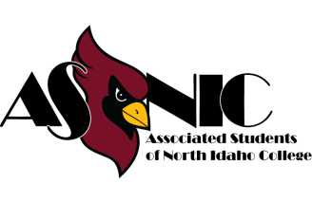
ASNIC Club Advisor Agreement

Responsibilities of ASNIC Club Advisors

Advisors to student organizations at NIC provide important assistance to student leaders. Advisors assist student groups to be effective in accomplishing organizational goals while helping enrich the personal and social development of students involved in student activities.

Each ASNIC Club must have an advisor who is a full-time employee of NIC. Student organizations may have co-advisors who are not NIC employees.

Advisors assist student clubs and organizations in the following ways:

- Serve the club as a resource person to student leaders; knowledge of policies and procedures, benefits, and opportunities that enhance the club’s goals and objectives.
- Assist students in the development and implementation of programs, activities, and/or events in order to achieve group goals and objectives.
- Attend group meetings, scheduled events, and trips. Advisors are required to travel on club trips.
- Assists students in adhering to college and ASNIC policy and procedures. Review and become familiar with the material in the ASNIC Club Handbook published by ASNIC.
- Assist the club in supervising the financial activities of the group using procedures established by the college business manager. Approve payment request forms submitted by student leaders when required.
- Attend required club advisor training sessions.
- Work closely with the Club members and Student Development staff in resolving problems that may arise with specific organizations, student leaders, and/or student-sponsored events.
- Serve as a leadership role model and mentor to student members of the club or organization.

I, _______________________________________, accept the advisor responsibilities listed above for the

_________________________________________ Club, for the ____________ academic year.

Advisor Signature: ____________________________________ Date: ___________

Appendix D: Club Roster Template
Table 1 - Club Roster
[Club]
Member List
Position | First Name | Last Name | Phone | NIC Email Address
On-Campus Advisor
President
Other Executive Position
Five Members total required

Appendix E: Event Release Waiver


FIELD TRIP/EVENT CONSENT FORM

I, the undersigned “Participant,” have volunteered to participate in a field trip/event associated with North Idaho College located at 1000 W Garden Ave. in Coeur d’Alene, ID scheduled for _____________________, 20____. Participants must read and sign the field trip/event consent form prior to the departure of a field trip or the beginning of an event. In addition, students who are under the age of 18 must have the signature of a parent or guardian. Participation is limited to students registered in the class or program sponsoring the field trip/event.

I, the undersigned, have enrolled and intend to participate in the North Idaho College-sponsored field trip/event identified above. I acknowledge that I have read the course/program outline and voluntarily accept such risks normally incident to such activities. I agree to hold North Idaho College, and all its officers, agents, and employees, free from liability in the event I suffer personal/property injury or damage as a result of participating in this field trip/event.

I further agree that I am solely responsible for my own equipment, supplies, personal property, and effects during the course of the field trip/event. I agree that all parties above whom I have hereby held free from liability are only responsible for the general supervision of the logistical/educational aspects necessary to provide a safe and successful field trip/event, and that they cannot and do not guarantee my personal safety.

I further agree that if I drive or provide my own motor vehicle transportation to, during, or from the program site, I am responsible for my own acts and for the safety and security of my own vehicle. I accept full responsibility for the liability of myself and my passengers, and I understand that if I am a passenger in such a private vehicle, North Idaho College and its personnel are not in any way responsible for the safety of such transportation and that North Idaho College insurance does not cover any damage or injury suffered in the course of traveling in such a vehicle.

In the event any medical attention is needed, I authorize the leader(s) of the field trip/event or any qualified individual to administer the first aid necessary to maintain health until a physician may be reached or other medical assistance obtained. By my signature below, I hereby agree to and fully understand all of the above issues/conditions and to accept full responsibility as outlined above.

DATED:________________/________________/20___________.
PARENT/GUARDIAN-PRINTED NAME:______________________SIGNATURE:_____________________________
PARTICIPANT PRINTED NAME:_____________________________SIGNATURE:_____________________________
STUDENT ID:____________________________________ EMAIL:__________________________________________ EMERGENCY CONTACT:___________________________________ PHONE:_________________________________

Appendix F: Club Annual Renewal Form

Club: Annual Renewal From

Club Name: Date:

Advisor: Email:

(If the club has a new advisor, a signed Advisor Agreement must also be submitted.)

Officers

Officer Position Title (1): Officer’s Name:

Officer Position Title (2) Officer’s Name:

(Two officers are required. Please list any additional officers on backside of this form.)

Please update below any changes made to the club mission statement, member requirements, narrative, or other information you want prospective members to know about your club (to be added to your club’s contact page):

Please return this completed form to
The Department of Student Involvement, ASNIC Offices in the SUB, room 233.

Appendix G: Cub Semester Overview From

Club: Semester Overview Report

Please fill out this form at the end of every semester in which the club is active. The information you provide here will be used to gauge the level of involvement and impact of your club on campus and in the community.

Club Name: Date:

Advisor: Email:

(If the club has a new advisor, a signed Advisor Agreement must also be submitted.)

Number of club meetings: Estimated number of attendees:

Did the club host any events (yes/no)? If yes, how many attended?

Was the club involved in outreach, student support projects, or travel during the semester, such as volunteering, workshops, conferences, tournaments, etc.? If yes, please include here:

Did the club host any campus events during the semester? for events or projects? If yes, please include here:

If more space is needed, please continue on an additional sheet.

Fall reports should be submitted by January 1st and spring reports should be submitted by April 15th to be eligible for that year’s club awards.

Please return this completed form to
The Department of Student Involvement, ASNIC Offices in the SUB, room 233.

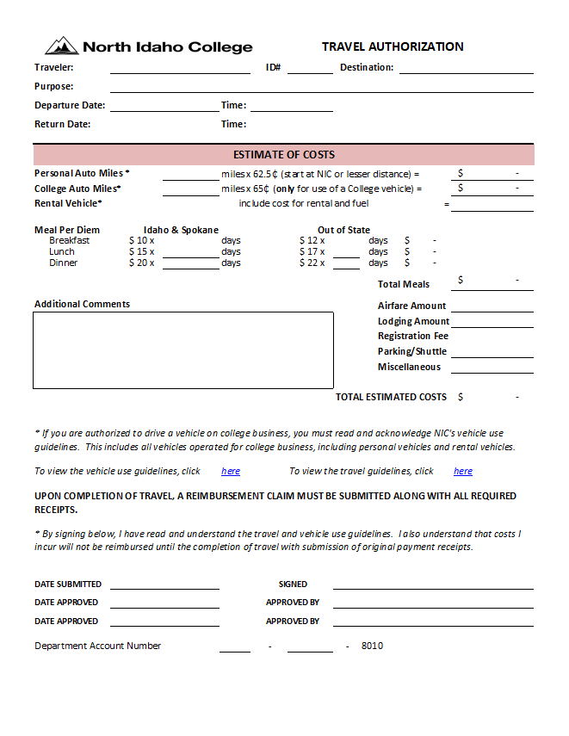
Appendix H: Travel Authorization Form

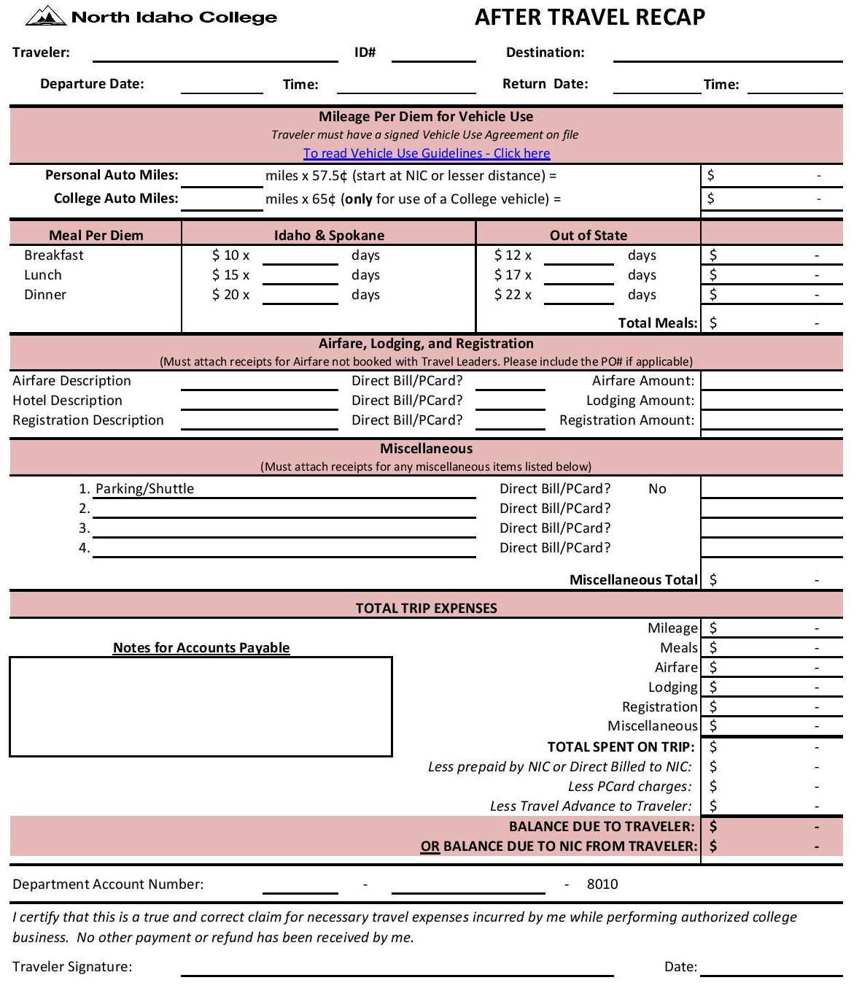
Appendix I: After Travel Recap Form

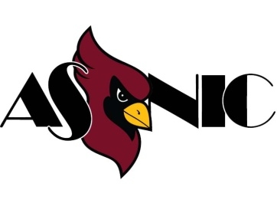
Appendix J: ASNIC Club Deposit Form

ASNIC Club Deposit Form

This form requires full completion with appropriate signatures and supporting documentation. Please return the completed form to the ASNIC Accountant in the Auxiliary Services Student Union Operations Office accompanied by the deposit.

Table 1 - Club Info
Event Date(s)
Date Submitted
ASNIC Club Name
ASNIC Club Account Number
ASNIC Club Representative Name
ASNIC Club Representative Signature
Deposit Activity (Fundraising, Donations, etc.)

Table 2 – Deposit Details
Deposit Detail
Currency |  | Amount ($)
Penny ($.01)
Nickel ($.05)
Dime ($.10)
Quarter ($.25)
½ Dollar ($.50)
Silver Dollar ($1)
One ($1)
Two ($2)
Five ($5)
Ten ($10)
Twenty ($20)
Fifty ($50)
One-Hundred ($100)
Number of Checks
Total Deposit

Table 3 - Approval Info
 | ASNIC Representative Use Only | ASNIC Accountant Use Only
Date Received | / / | / /
Amount Received ($)
ASNIC Representative Signature
Deposit Date |  | / /
Colleague Journal Number
Colleague Journal Date |  | / /
Colleague Entry Date |  | / /

Appendix K: Reward or Prize Audit Tracking Form

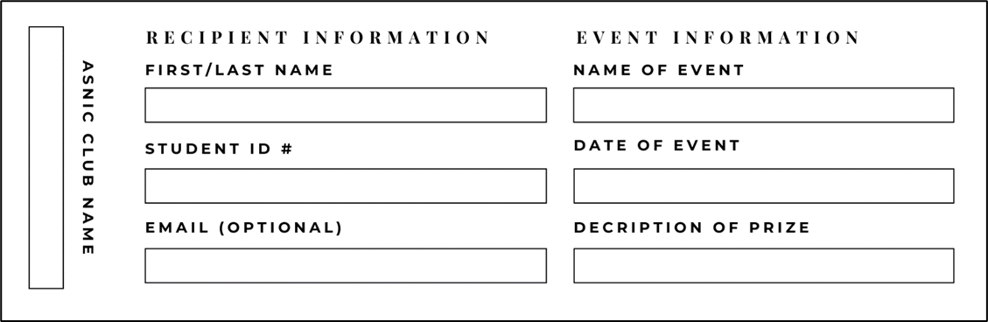

Appendix L: ASNIC Purchase Order/Payment Request Form

